Library Management System – Project Report

Introduction :

This project implements a Library Management System that supports book management, member registration, and essential operations such as adding, removing, borrowing, and returning books. The system also includes an Undo mechanism that reverses previously executed actions. It is designed using object-oriented programming principles and makes extensive use of data structures such as linked lists, stacks, queues, and trees to ensure efficient data handling.
To ensure project authenticity, two unique student IDs (230316058 and 230316024) are integrated directly into the system logic. These IDs are used when generating unique book identification numbers in the Book class and user identification numbers in the User class. This mechanism guarantees student-specific behavior and ensures that all generated identifiers remain globally unique.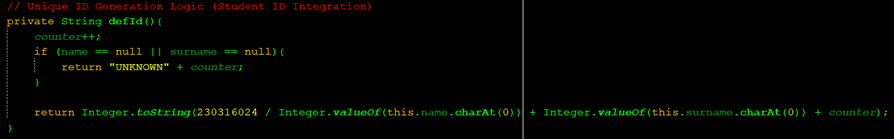

- Design Decisions :
  - Single Linked List :
We used single linked list structure in this project to manage data that requires sequential access and frequent insertions or deletions. Unlike arrays, linked lists do not require contiguous memory allocation, making them more flexible when dynamically adding or removing elements during runtime.
In this project, the Single Linked List is used for storing loan history records that benefit from dynamic growth. Each node contains a reference to the book and a pointer to the next node in the list.
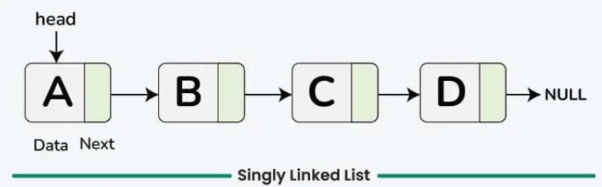

  - Binary Search Tree :
We used Binary Search Tree (BST) structure in this project because one of our primary goals was to reduce time complexity and support optimized lookup operations. A balanced BST provides an average-case time complexity of O(log n) for search, insertion, and deletion. In contrast, using an array or a linked list for the same operations would result in O(n) time complexity, making them less efficient for larger datasets.
In the project, the BST is used to store information related to books (organized by their title or author) and users. Using a tree structure allows all entries to be automatically arranged in sorted order, which simplifies alphabetical listing and fast searching.
The BST implementation includes the following methods:
add, search, save, delete, minValue, showAlphabetic, inOrder.
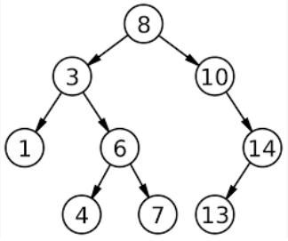
Each node in the tree holds either a book object or a user object, depending on the tree’s purpose. This structure ensures efficient data manipulation and supports both ordered traversal and fast retrieval.
  - Queue :
We used a Queue structure in this project to handle operations that require first-in, first-out (FIFO) ordering. A queue is ideal for situations where the earliest entered element should be processed first, ensuring fairness and predictable data flow.
In this project, the Queue is used for managing waiting lists for popular or currently borrowed books. Each node in the queue holds a user object.
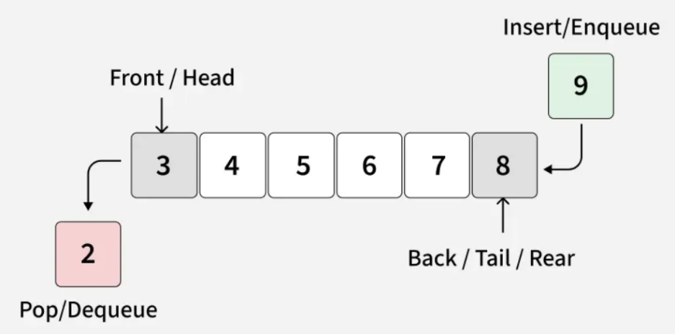
2.4 Stack :
We used a Stack structure in this project to implement the Undo mechanism, which allows the system to reverse previously executed operations. A stack is the ideal choice for this feature because it follows the Last-In, First-Out (LIFO) principle, meaning the most recent action is always the first one to be undone—exactly matching the expected behavior of an undo system.
/////////////////////////////////////// …
2.5 Popularity Heap :

2.6 Hash Table :

